**Non Motor Dynamic Screen Configuration**

Screen Link - <http://192.168.1.99:4020/>

Admin Login – admin02 / Admin@01

For Configuring a Project – need to create Project Details under Modules Menu Section

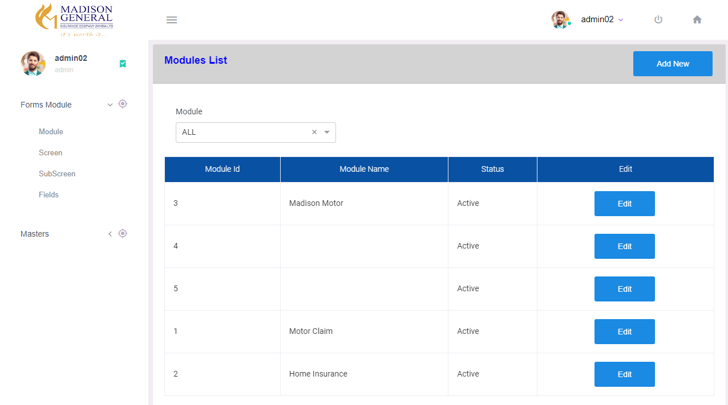

Click Add New button For Add New Project Details

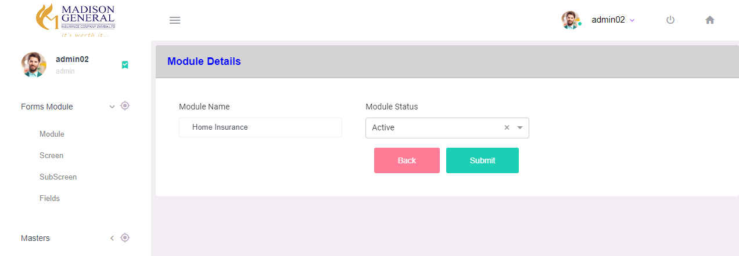

Each Project Will Contains Multiple Screen Section – Existing Screen List can Be Found under Screen menu Based on Project Selection

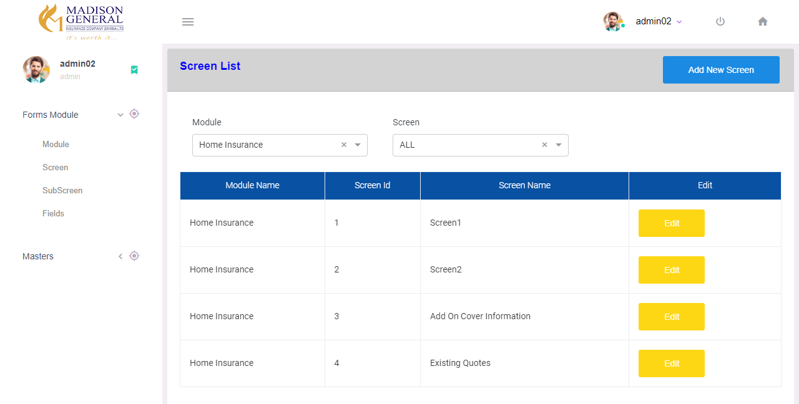

Click Add New Screen for Adding New Screen on the Selected Project

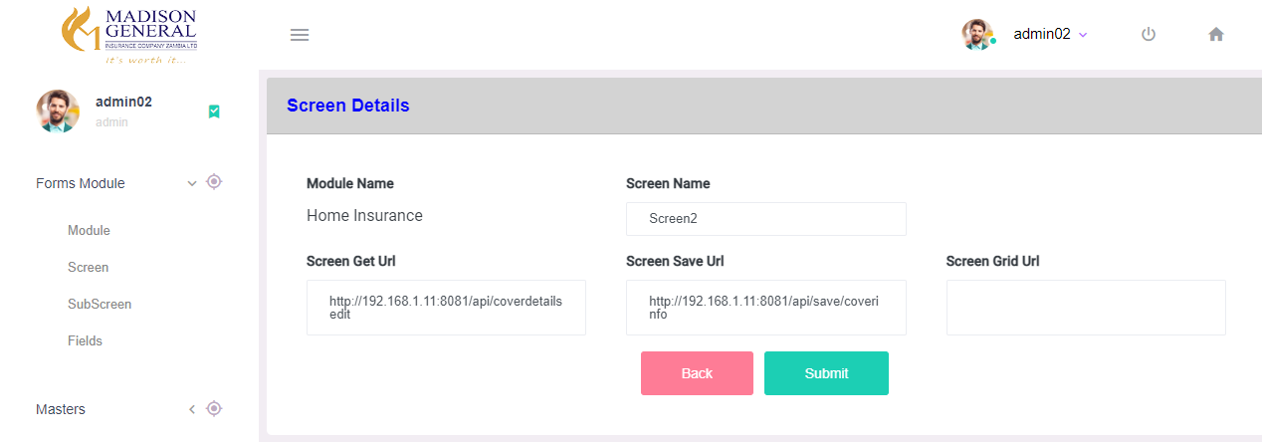

Screen Name – Screen Name is Stored to Display as Main Title on Rendering Page

Screen Save Url – If Screen Contains Any Form the save api url is stored in this field

Screen Get Url – If Screen contains Any FormSection – to get the saved details the api urll stored in this field

Screen Grid Url – If Screen Contains any Table – Get table Details Api Url stored in this field

Each Screen will contains Single or Multiple SubScreen Section – View Subscreen Details Based on Project & Screen Name in SubScreen Menu

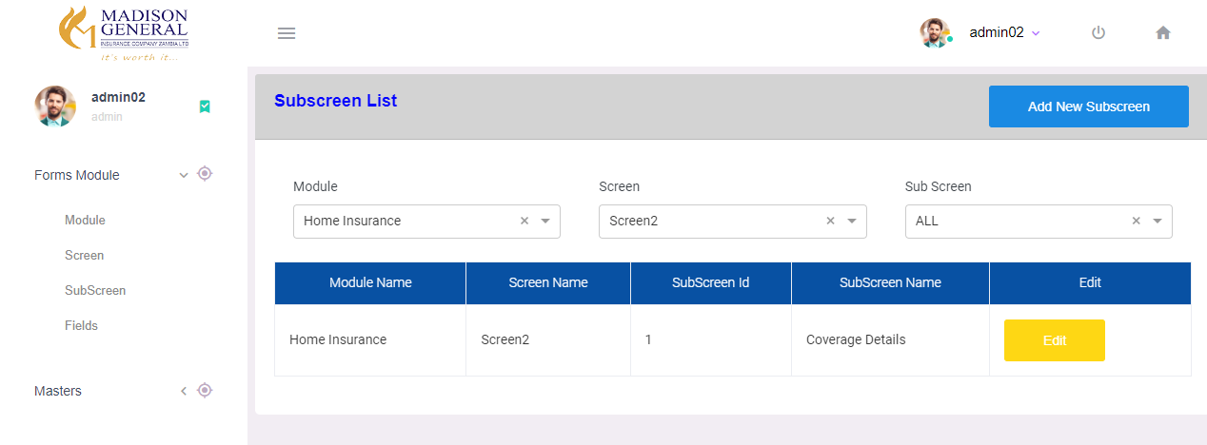

For Add new SubScreen – Click Add New SubScreen

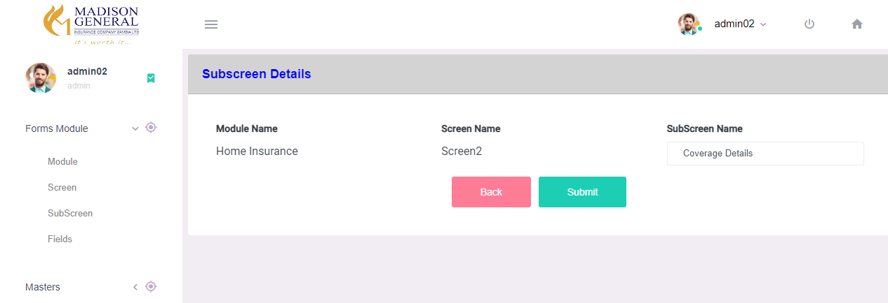

SubScreen Name – Name Stored to Display as Sub-Screen Title on Rendering Page

If Sub-Screen Contains Any Form Section – Single or Multiple Fields Can be Configured to the Respective Sub-Screen

Existing Fields List can be Found on Fields Menu – Based on Project, Screen, SubScreen Selection

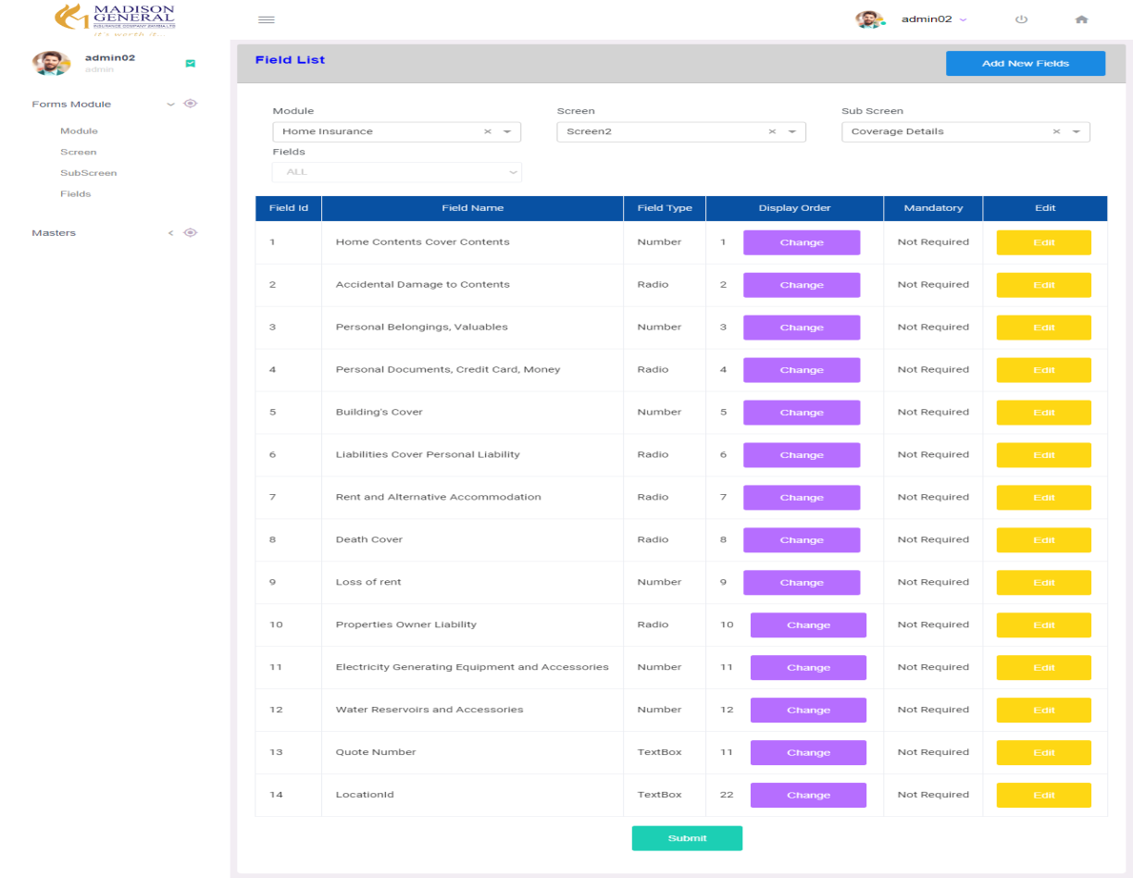

Click on Add New Fields – For New Field Insert

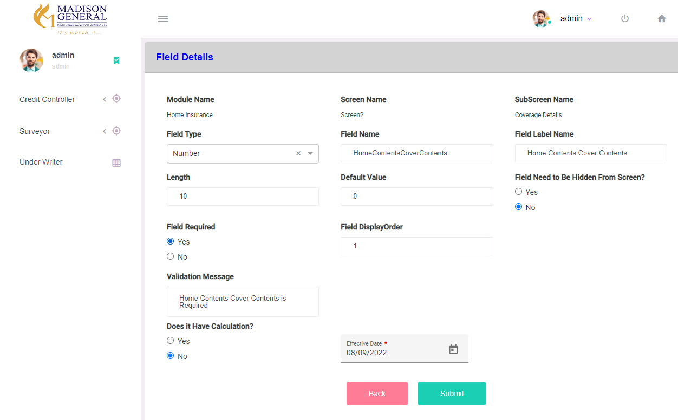

Field Type - Field Type can Be TextBox, TextArea, Radio, Dropdown, DatePicker,Checkbox

* Based On Field Type Selection Field Details will be Shown

Field Name – Value Stored to pass as Key in Submit Api

Field Label Name – Value Stored to Display Label Name for field on Rendering Page

Length – Maximum Length of Field

Default Value – If Field contains Any Static Value, it can be Stored

FieldneedtoBeHidden? – Based on Selection Fields Can be Shown/Hidden on Screen

FieldRequired? – Field Mandatory or not

Validation Message – Based on Field Required Selection Validation Message Field Shown – Mandatory Message are Stored to display for empty Validations

Display Order – Field can be Displayed in Screen Based on the DisplayOrder value

If Field Type – Dropdown/Radio -

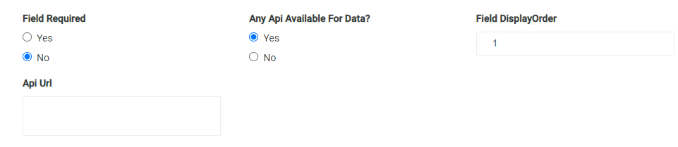

Any Api Available? – If Dropdown/Radio Field Option is load by any Api

Api Url – Url for Dropdown Api Call

If there is no Api Available – Static Options Can be Stored as Shown Below

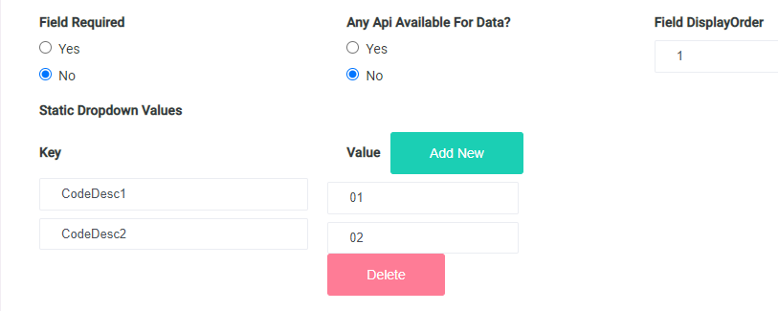

Does it Have Calculation? – If Field Contains any Inbuilt Api Calculation – this can be Selected

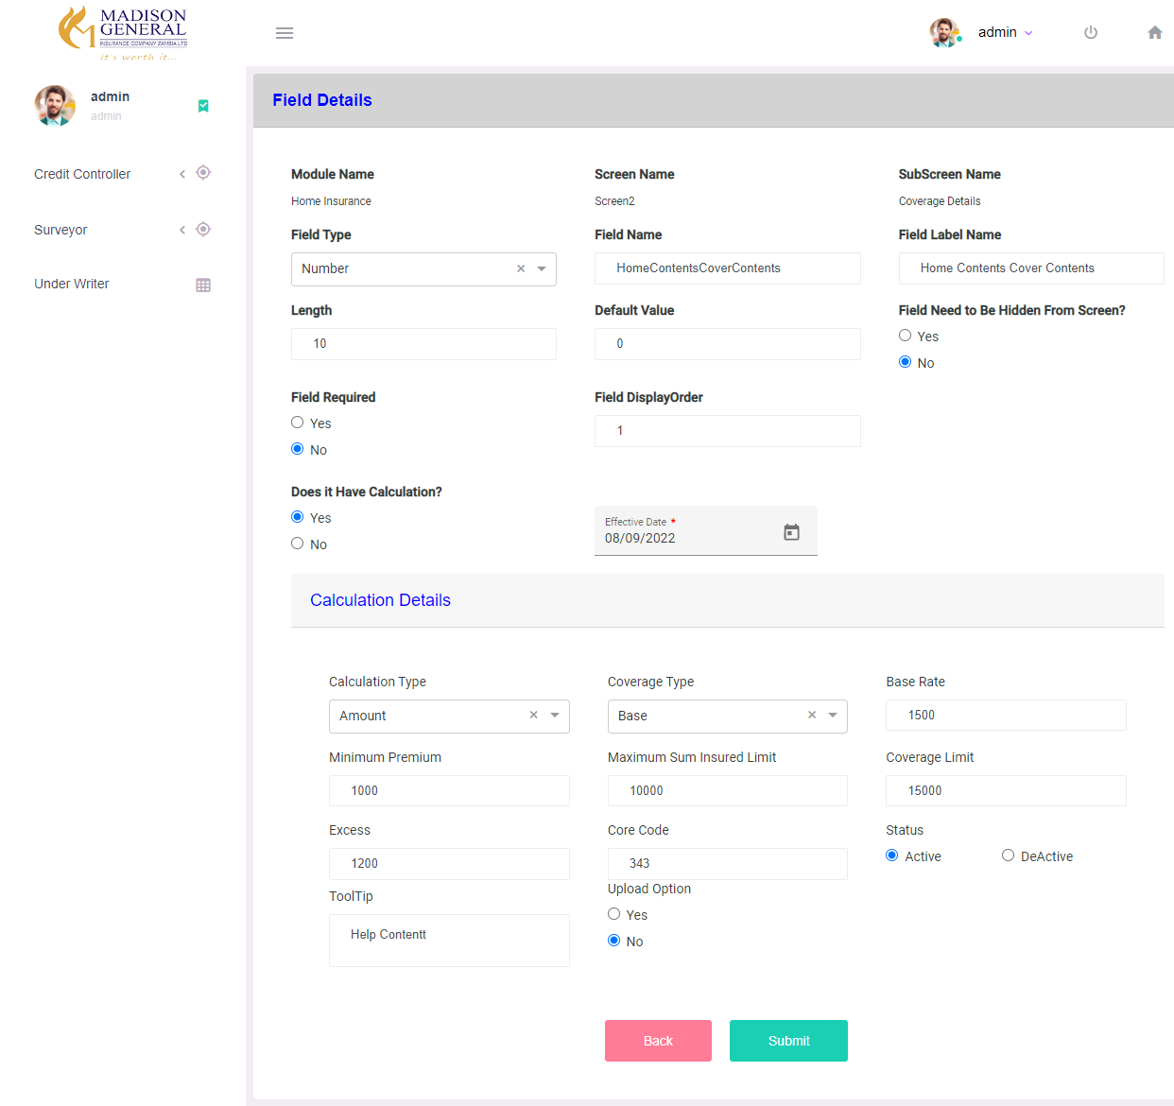

Calculation Details –

CalculationType – If typeOf calculation is Amount / Mile / Percentage

BaseRate, Minimum Premium, Maximum SumInsuredLimit can be stored for Calculation

If Calculation Type is Grid – Minimum SI Limit, Max SI Limit, Min Premium, Base Rate Details can be stored as Multiple Rows as Shown Below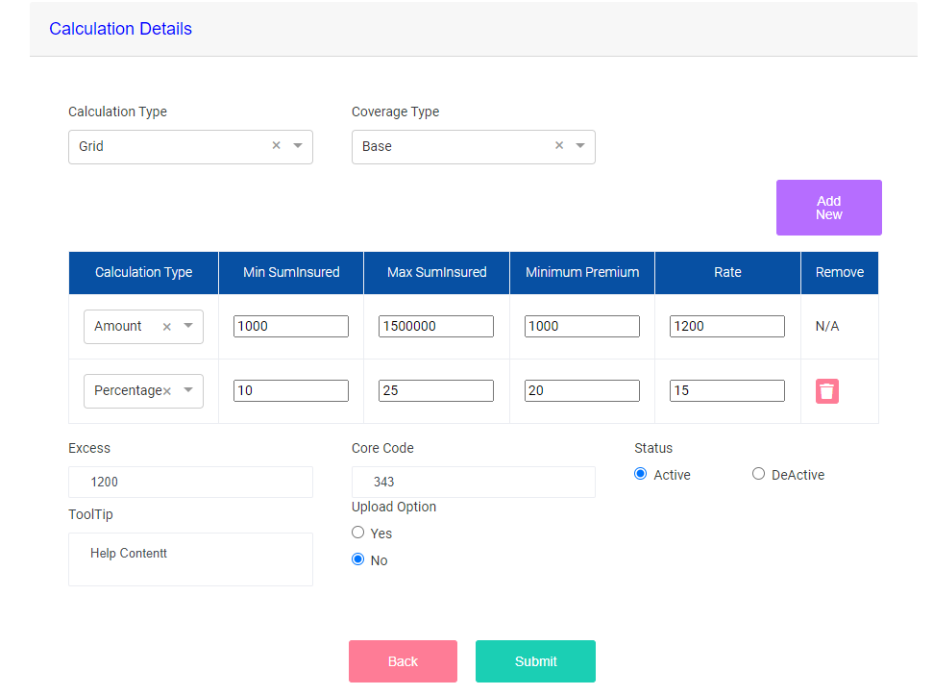

**Product & Coverage Configurations**

Product Master –

Configure Products Under Product Master Menu –

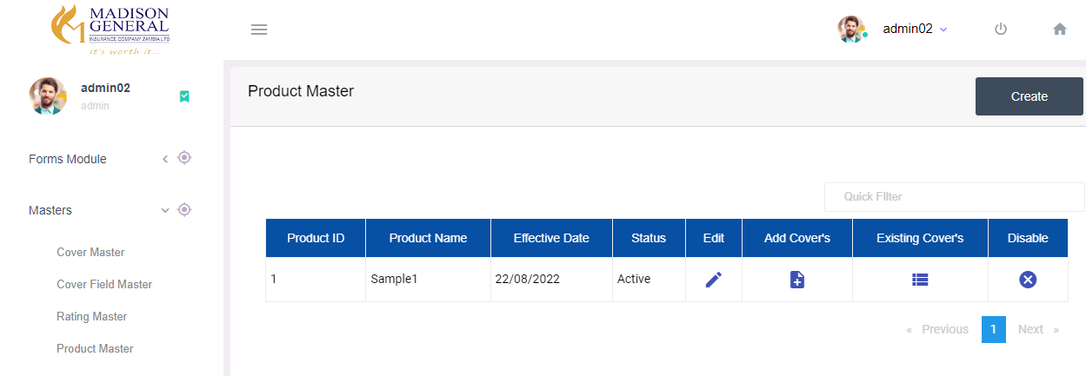

For Add New Product – Click Create Button

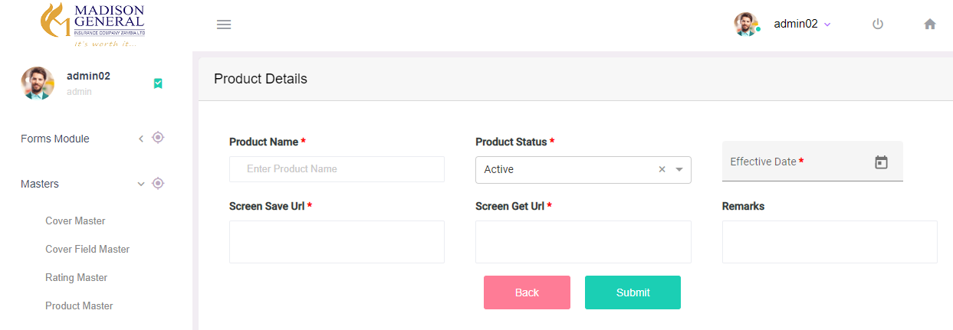

Product Creation is Same Like Module Creation Process

**Cover Master –**

Existing Covers can be seen on Cover Master Menu

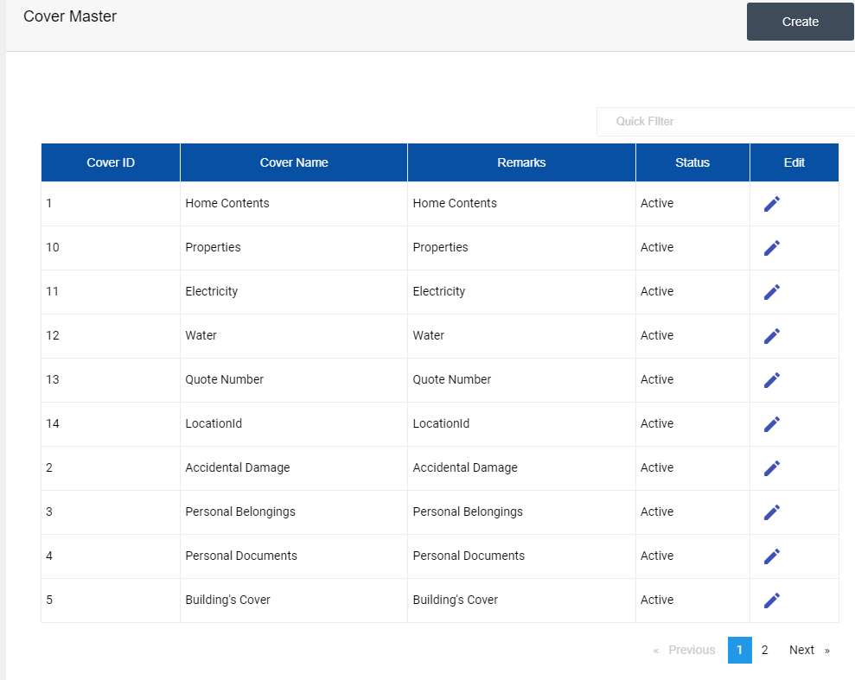

For Add New Cover Click on Create Button

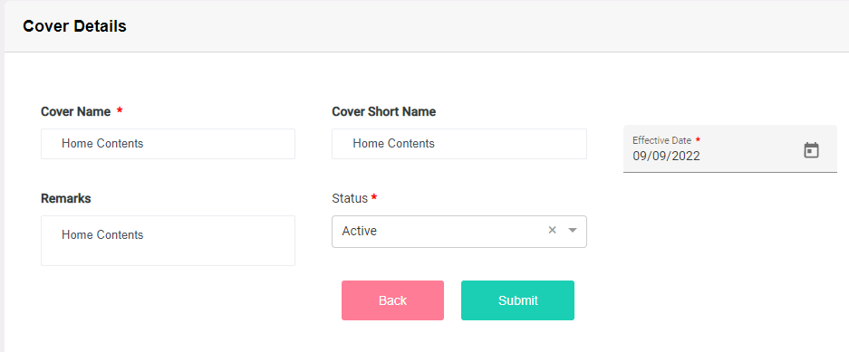

**CoverField Master**

Each Cover may contain Single or Multiple Field Details,Existing Field Details seen on Cover Field Master Menu

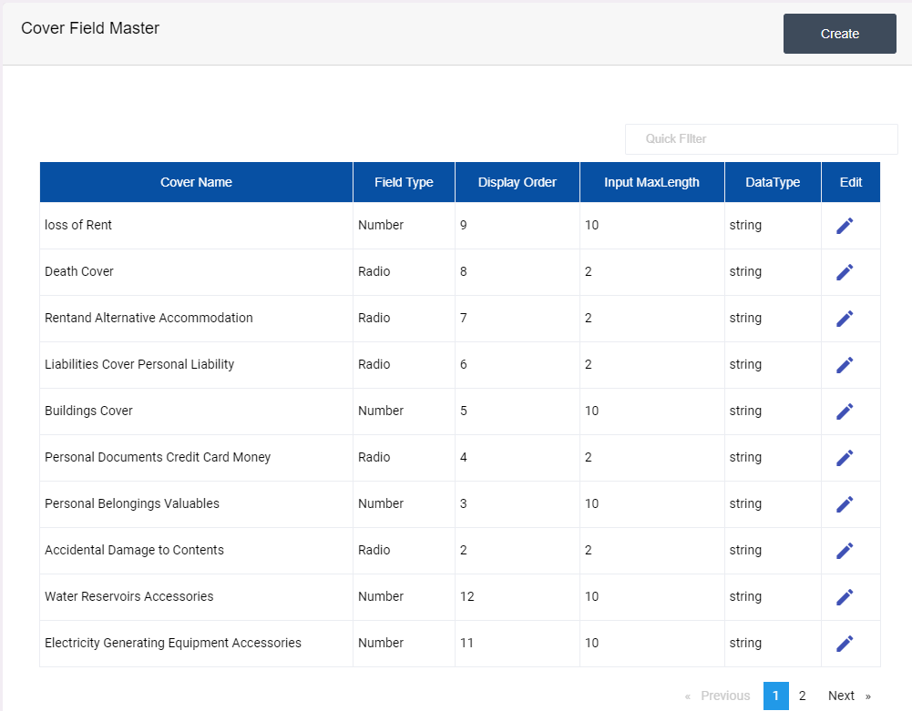

For Add new Cover click CreateNew button

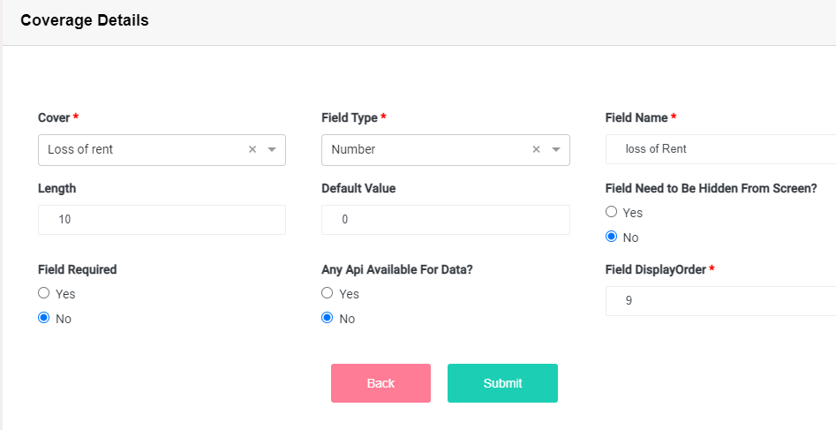

Cover Field Details Is Same Like Field Master Creation Process

**Rating Master**

Claculation Details For Each Cover Master Can be Configured in Rating Master, Existing Rating Masters can be Seen Under Rating Master Menu

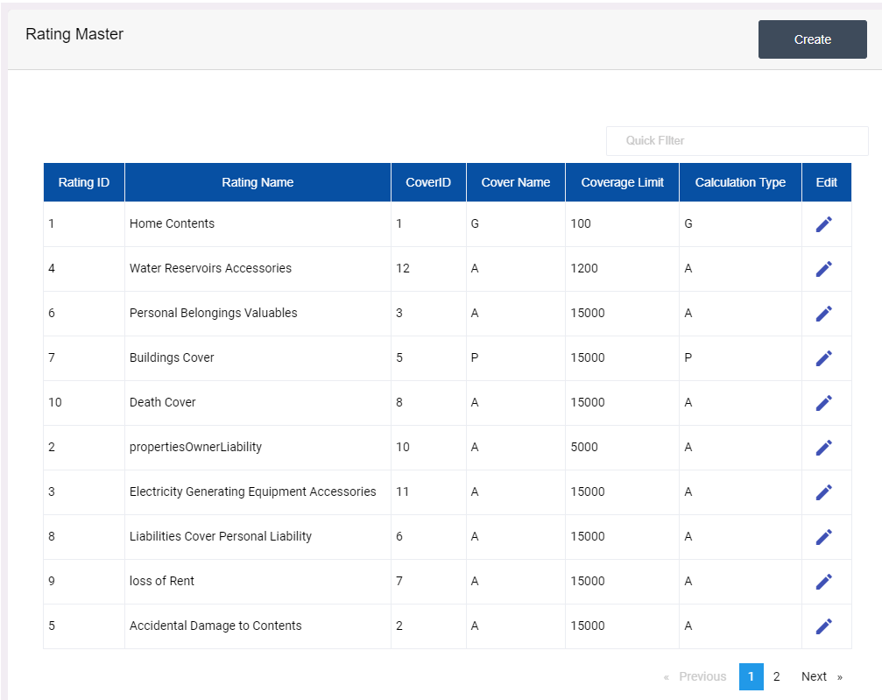

For Add New Rating Click Create button

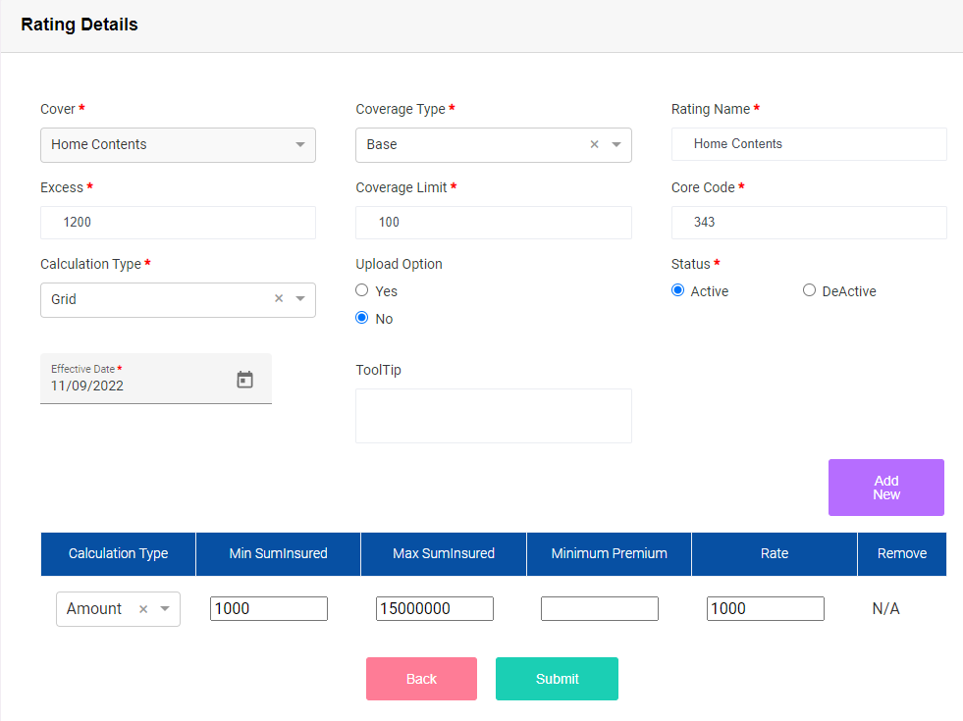

Field Calculation Details Creation Details are Same stored in Rating Details Form

**Product Cover Master**

Product Based Cover Insert Can Be Done in Product Cover Master. Existing Product Based Cover List can be Found in Product Master List – Exising Covers Button – If there is no Existing cover Available under a Product – button will be hidden

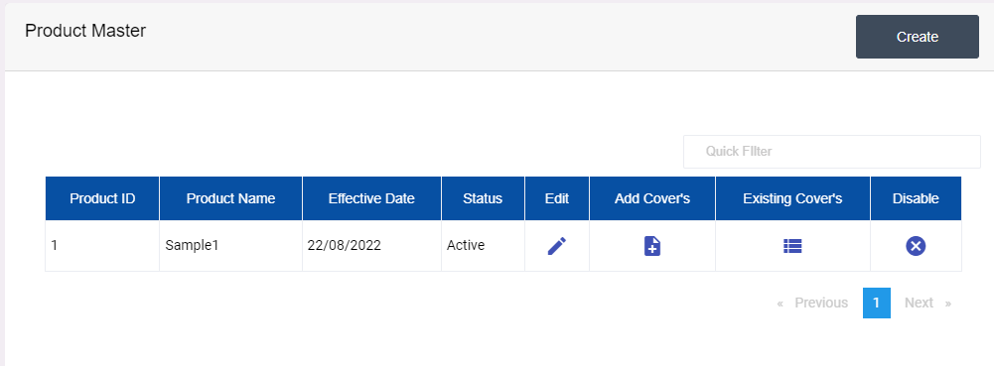

For Add New Cover Under a Product Click on Add Cover Button

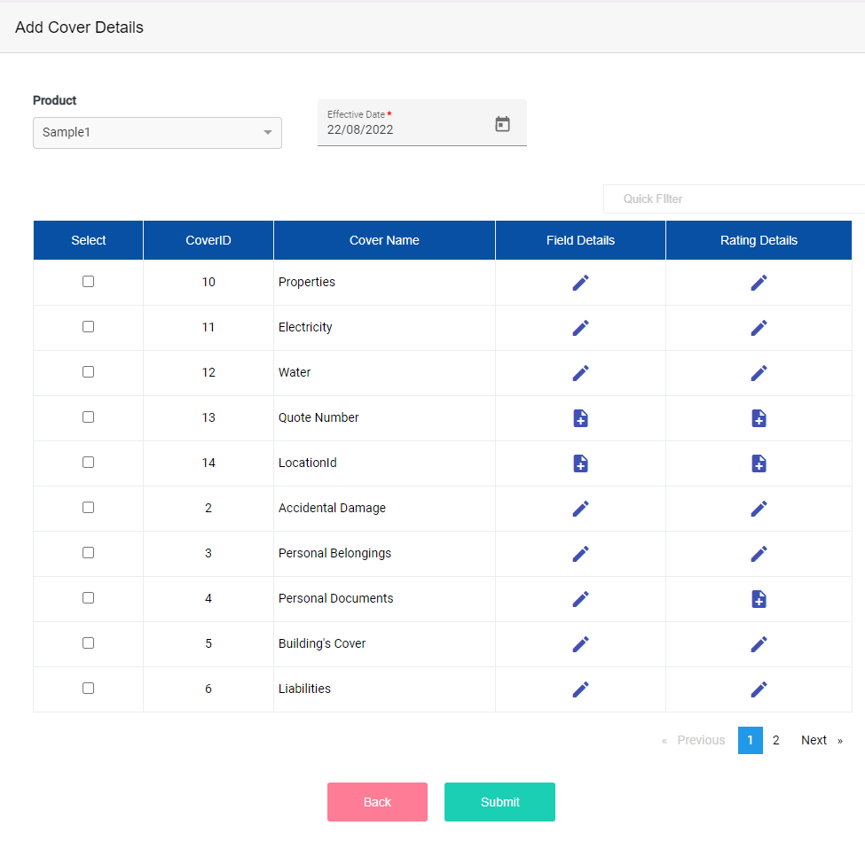

On Existing Cover List Details – Cover Based Field Details & Rating Details can be Added Directly

**Rendering Screen Details**

User Login – marshbroker / Admin@01

Based on User Login – the Product Details Will be shown as Product List Configured in Product Master

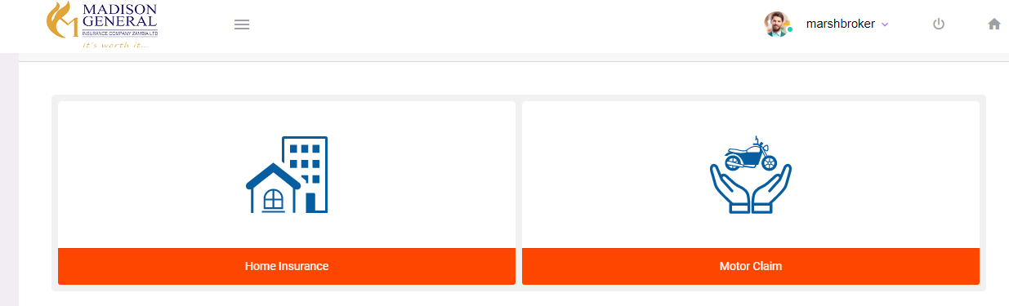

For Example - If Product – Home Insurance is Selected – the Home Insurance Based COveer List Can be Rendered on the Upcoming Pages

Now Clicking on the Home Insurance Product

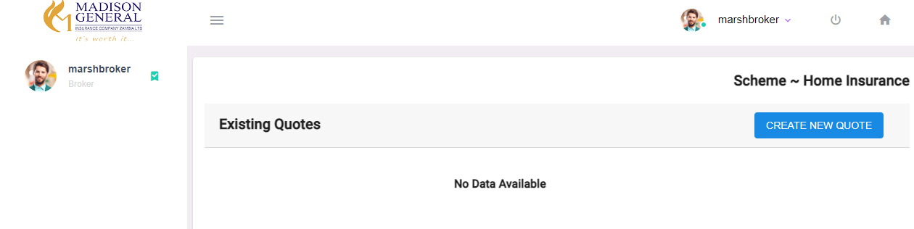

The Existing Quote page is Default Rendering Pagen from Module Id Based Screen Configuration – Quote List Can be Viewed on this page Based on Product Selection, For creating new Quote – click on Create New Quote Button

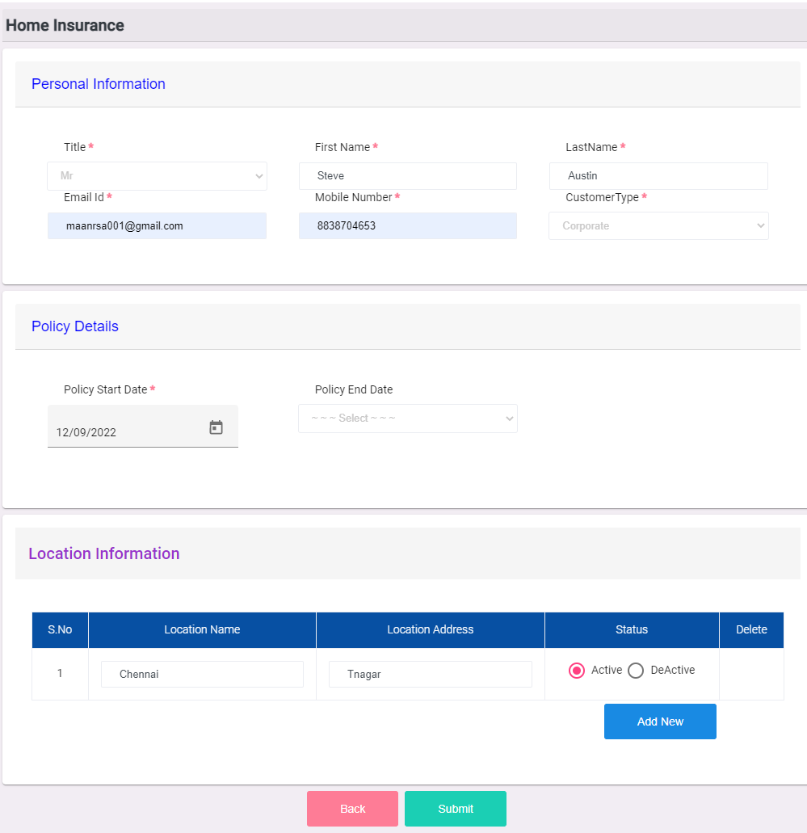

Basic Details of customer Can be stored on this Dynamic Rendering Page – Personal information, Policy Informations are Subscreens Rendered Dynamicaly from Configured Details, Location Information Subscreen is made Static Design.

Once all Mandatory Details entered & submitted, If the Location is Single Data – the Coverage Loading Page Will be Directly Rendered as shown below

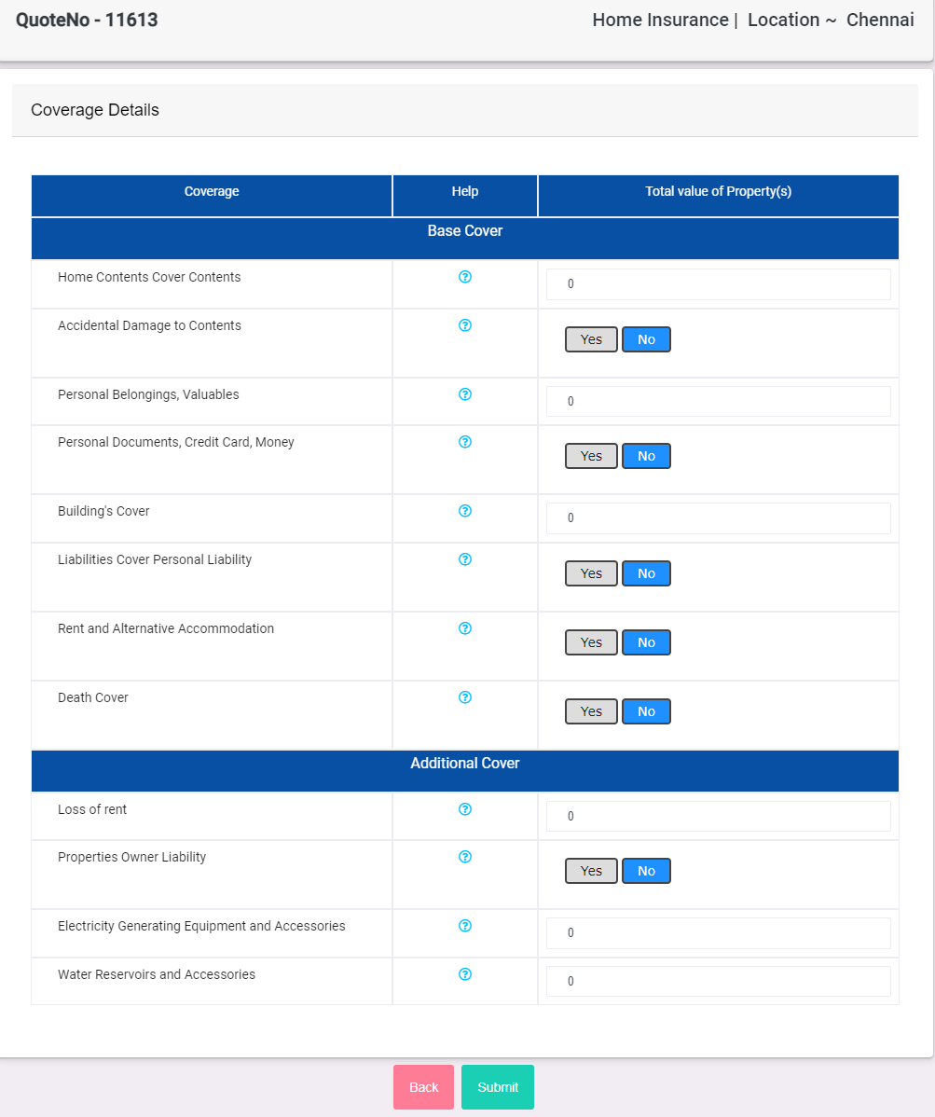

The Coverage List Shown above are Rendered From Product Id Based Cover Configured on Admin Login

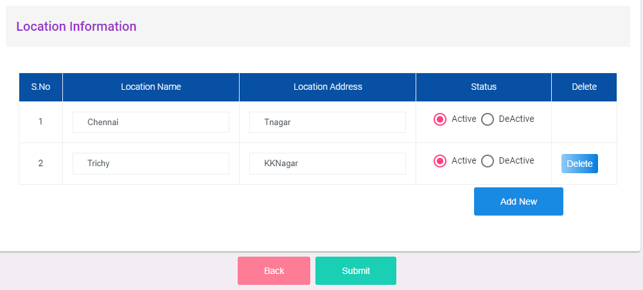

If there is Multiple Location Details Stored like shown Above,then the Coverage Rendering Screen will be Like Shown Below

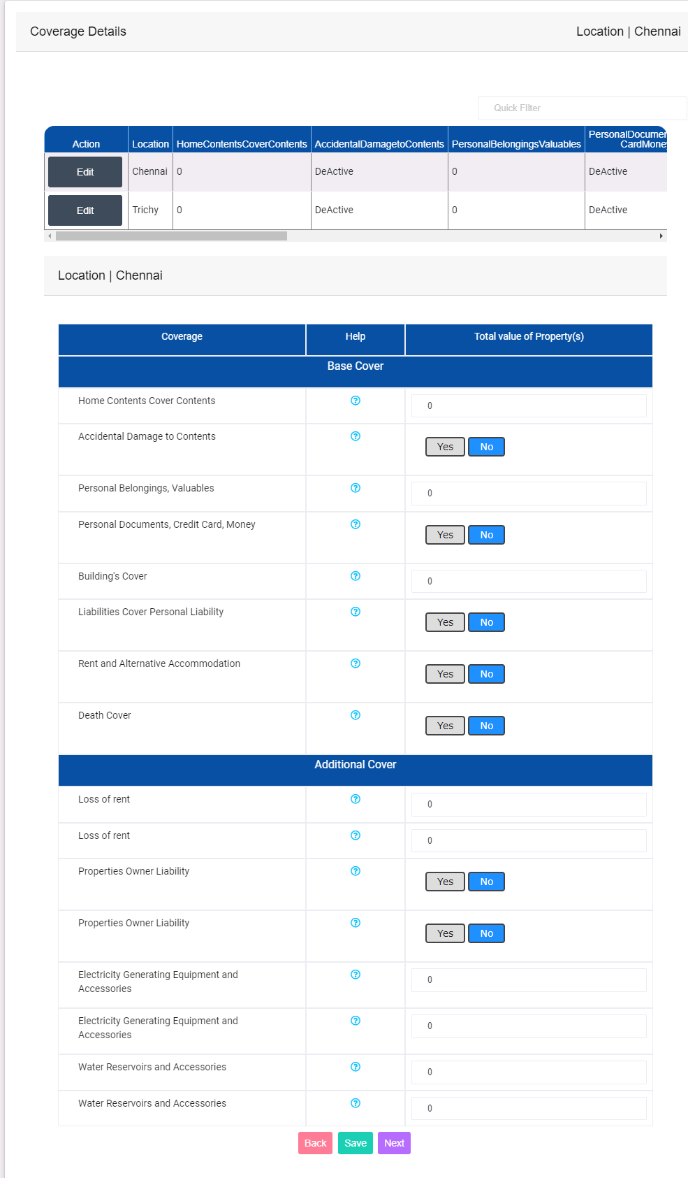

Each Location Based Coverage Value Can be edited from the location list grid Details

Atleast One Cover Must Contain Value > Minimum Premium configured in Field Master (if it is number field) or Value – Yes (if it is Radio button) & Proceed to next Page

Selected Covers Based Premium Details Can be Shown on Next Page like shown below

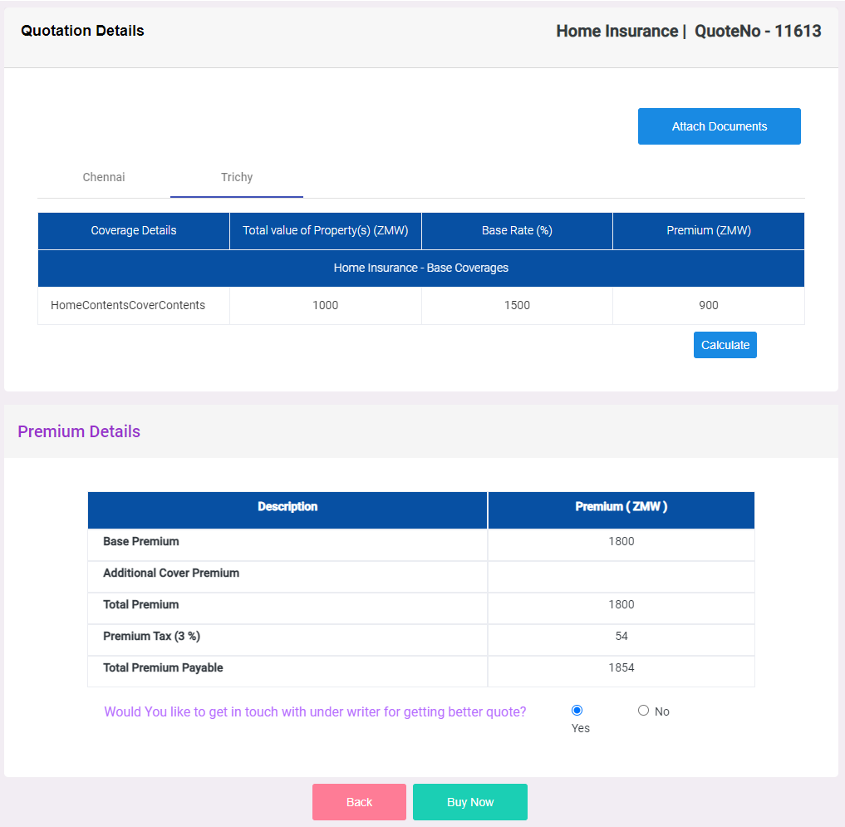

On Click Buy Now Button From Premium Details Page, the Cover Based SubCover Details Adding Page will Be Rendered as Below

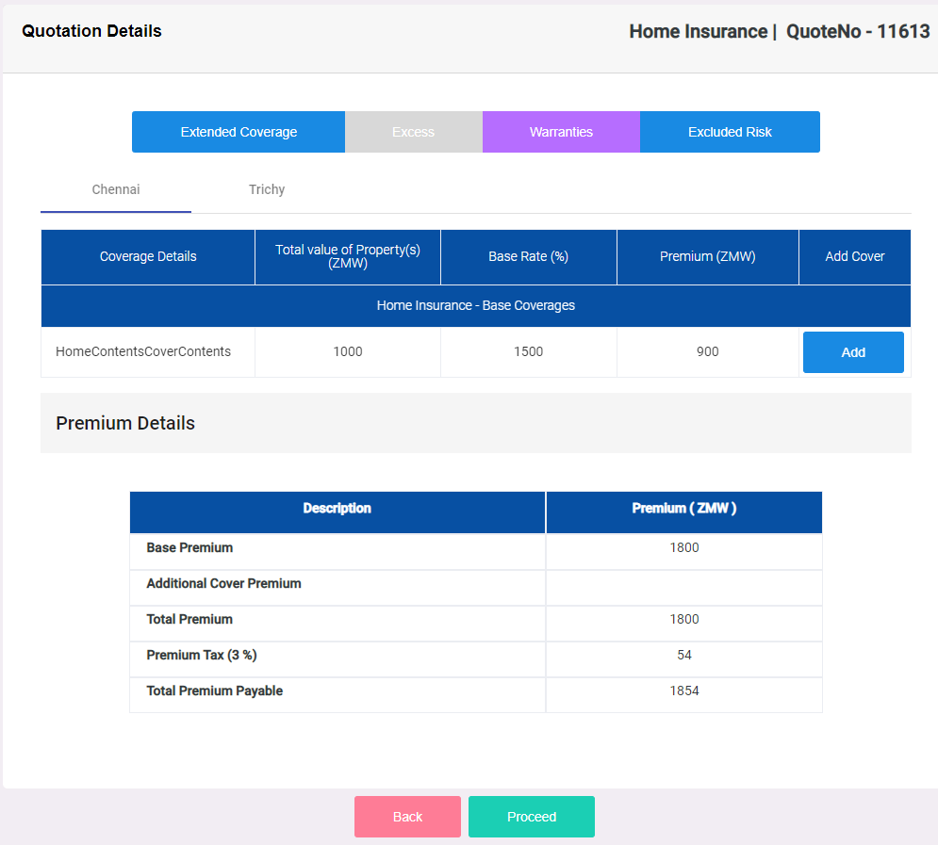

Extended Coverage, Excess, Warranties & Excluded Risk Details Can be Added From the Respective Buttons Shown on top

If there is any SubCover Available for Selected Covers – click on Add button on Respective Covers Row

SubCover Details Insert Page will be like shown below

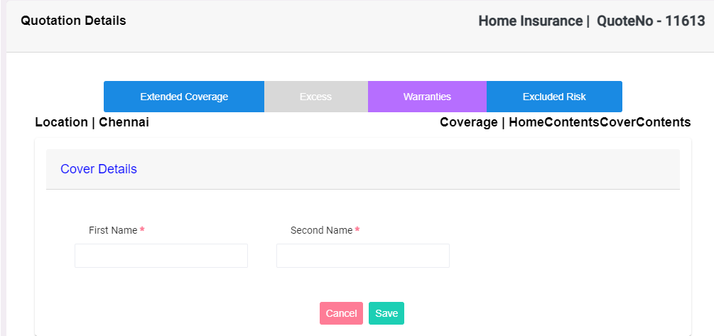

After Adding SubCover Details & click on Proceed Button, Final Part of Quote Insert Flow is Storing Policy Holder Information of Customer Page Will be Rendered as Shown below

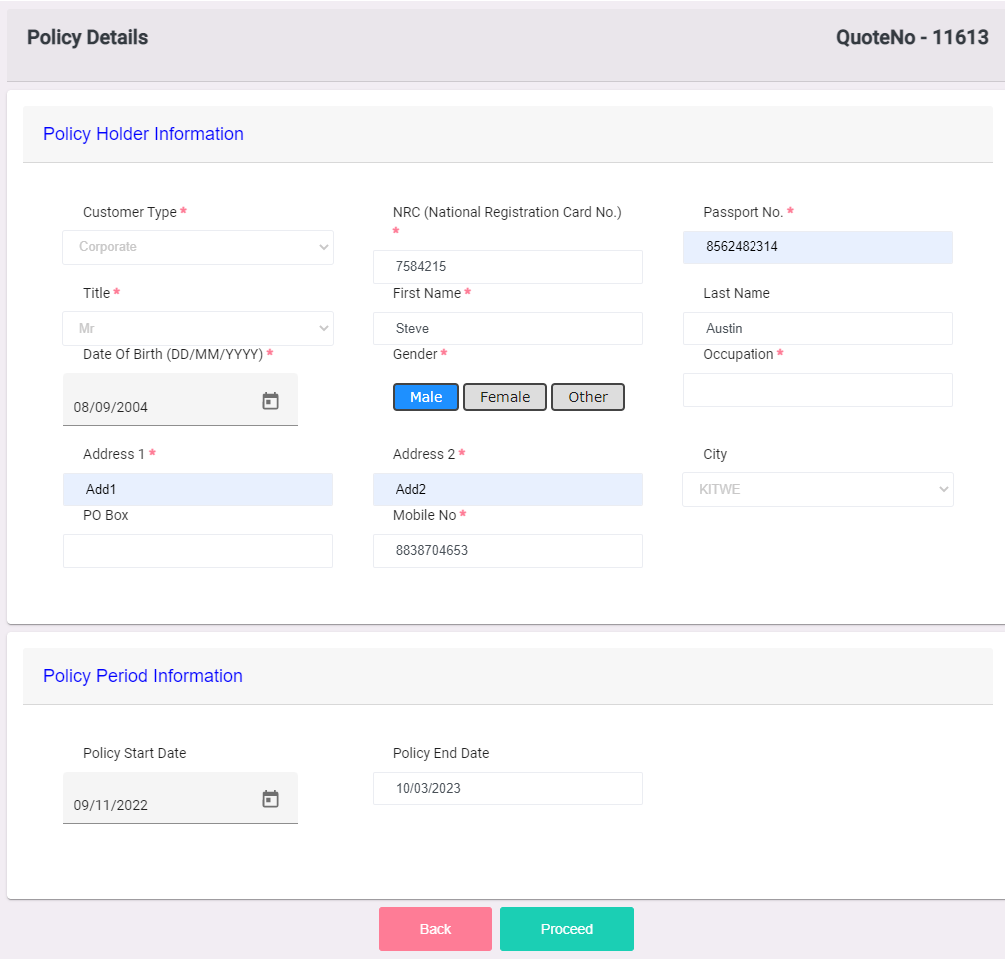

On Submitting the Form with Mandatory Details Filled, the Quote will be Created Successfully & found on Existing Quotes Grid